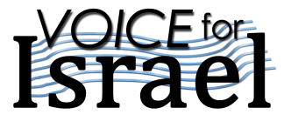

**Voice for Israel**

**Join us for an exciting & prophetic tour to Israel Oct 18 -27, 2017**

**Led by**

**Hannah Nesher & Family**

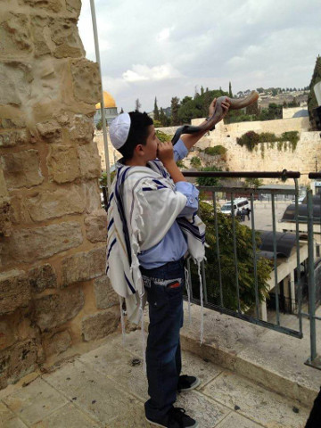

$2960 per person

**TOUR PACKAGE INCLUDES**

* **Return flight out of Edmonton**
* **Service of Yaffa Tours in Israel**
* **Meeting assistance and transfer on arrival and departure**
* **Guided Sightseeing Tour**
* **Hotel accommodations**
* **Breakfast and dinner daily**
* **English speaking Licensed Guide**
* **Deluxe Air-Conditioned Bus**
* **Admission Fees**
* **Final Documents/Information Kit**

**NOT INCLUDED**

* **Insurance**
* **Departure Taxes $700**
* **Tips $110 USD**
* **Single room supplement $850**
* **Eilat Extension includes**

**2 nights and flights**

**For credit card payment call Sunworld Tours**

Please forward to Sunworld Tours a non-refundable deposit of $200 per person along with the registration form and a photocopy of the first page of your passport.

Final payment is due Sep 1, 2017.

Cancellations: 25% refund of total tour cost

45-31 days prior to departure

No refund 30 - 0 days prior to departure

For information and registration contact

**HANNAH NESHER   
Phone: 780 903 5002** ♦ [www.voiceforisrael.net](http://www.voiceforisrael.net)  
**Email:**  [nesher.hannah@gmail.com](mailto:nesher.hannah@gmail.com)

**SUNWORLD TOURS**   
#337–17th Ave SW Calgary, AB, Canada T2S 0A5

Tel: 403 245 9181 ♦ Fax: 403 228 2408 ♦

Toll Free: 1 800 461 6854 ♦ [sunworld@sunworldtours.com](mailto:sunworld@sunworldtours.com)♦[www.sunworldtours.com](http://www.sunworldtours.com/)

Day 1 Wed Oct 18 Depart Canada

Depart Edmonton to Israel. Overnight en route flight

Day 2 Thu Oct 19 Israel

Upon arrival at the airport you will be met by Sunworld Tours representative and drive to Neot Kedomim to have an introductory seminar & Biblical gardens tour (olive press, wine press, etc). Free time to enjoy the beach and a walk along the Mediterranean Overnight in Tel Aviv area

Day 3 Fri Oct 20 Tel Aviv - Haifa

Tour the ancient seaport of Joppa. Continue to the Diaspora Museum telling the story of the Jewish People and their roots. Visit Dugit the Messianic outreach Centre. Travel north along the picturesque Mediterranean coastline to Caesarea having the opportunity to see the Archaeological ruins of the Roman Amphitheatre. Then we will ascend to Mt. Carmel where Elijah contested 850 false prophets and the God of Israel answered by fire. Stop at a Druze Village for a short visit Celebrate Erev Shabbat. Overnight in Haifa

Day 4 Sat Oct 21 Galilee

We begin our day travelling to Megiddo, the site of final battle of Armageddon. Take a swim at the Sachne. After lunch travel to Mt. Of Beatitudes where Yeshua preached the Sermon on the Mount and tour the ancient Capernaum where Yeshua spent much of his time during his ministry. May be having a Folk dance. Overnight at the Sea of Galilee area

Day 5 Sun Oct 22 Golan Heights - Sea of Galilee

Begin the day ascending up to the Golan Heights. Visit Caesarea Phillipi and Banias National Park. Enjoy a view of the area from Mt. Bental Bunker. See the Ancient Boat Museum (Kibbutz Ginosar) and sail on the worship Boat on the Sea of Galilee. Those wanting to have Messianic Mikvah will have opportunity to do it in Yardenit.

Overnight at the Sea of Galilee area

Day 6 Mon Oct 23 Dead Sea – Massada

This morning, travel south, along the Jordan Valley to Beth Shean the largest excavations of a Roman city in Israel. Stop at Qumran and on to Ein Gedi to hike up to Ein Gedi Falls. This is the desert oasis where David hid from King Saul. Take the Cable Car to the top of the mountain of Massada, Take a dip in the therapeutic salt mineral water of the Dead Sea. Overnight in Dead Sea area

Day 7 Tue Oct 24 Jerusalem

Enjoy a Camel Ride and Biblical Hospitality at Abraham’s Tent at Genesis Land. Enter Jerusalem as pilgrims have done for centuries and take in the panoramic view of the city from the top of Mt. Scopus. Drive to Mount Olives. Continue to the Garden of Gethsemane where Yeshua spent the night and agonized in prayer for God’s will to be done. On to Mount Zion to see King David’s Tomb and the Upper Room.

Explore the Jewish Quarter. Pray at the Western Wall and walk in the old city markets and visit the Holy Sepulcher. **End the day with a tour and communion at the Garden Tomb.** Overnight in Jerusalem

Day 8 Wed Oct 25 Jerusalem

Visit the City of David: watch the 3D movie of the history of the city and walk through the Hezekiah’s Tunnel and the Pool of Siloam. Enter the Old City of Jerusalem to Visit the Davidson Center and the original Southern Steps that led to the Temple. Lunch at Christ Church. Some free time to wander at Machne Yehuda market. A night out to see the Amazing outdoor Sound and Light Night show at the Tower of David Museum. Overnight in Jerusalem

Day 9 Thu Oct 26 Modern City of Jerusalem  
Plant a tree. Drive to see the Government Hill. Visit Yad Vashem, The Holocaust Memorial Museum. Proceed to the Temple institute at the Jewish quarter. The rest of the day is free.

Overnight in Jerusalem

Day 10 Fri Oct 27 Canada

Transfer to airport for flight back home

* Itinerary subject to change

###### Eilat Extension

Day 10 Fri Oct 27 Jerusalem – Eilat

Drive or fly to Eilat. Rest of the day is free

Overnight in Eilat

###### Day 11 Sat Oct 28 Eilat

Spend time at the beach, snorkel in the coral reef, swim with dolphins, see the aquarium there, some time for shopping

Overnight in Eilat

###### Day 12 Sun Oct 29 Eilat - Jerusalem Around noon drive or fly to Jerusalem

 Registration Form   
**Voice for Israel Tour with Hannah Nesher October 18 - 27, 2017** ♦ **Eilat Extension Oct 27 – 29, 2017**

Name 1 Date of Birth

As on passport Last / First /Middle Mr Mrs Ms MM/DD/YY

Name 2 Date of Birth

As on passport Last / First /Middle Mr Mrs Ms MM/DD/YY

Address   
 Street City Province Postal code Country

Phone Home Cell E-mail

€ I wish to have a single room - extra $850 I wish to room with

€ I wish to have a Full Package Insurance € Non Medical Decline

Please sign here stating you declined insurance

Meal on the plane € Regular € Vegetarian

I need connecting flight to Edmonton from Your name on the Tour

Eilat Extension Yes _____________________________ No